Nepal College of Information Technology
Unit Test
Fall 2012
Program : BE ELX Time : 2 hrs
Semester : (V) FM : 70
Subject : Control Systems PM : 35

- Candidates are requested to give their answer as far as practicable in their own words.
- The figure in the margin indicates the full marks
- Attempt ALL question

1. a) Define open loop and closed loop system with suitable examples. Which system is more reliable to operate? Explain with suitable reasons. [8]
b) A position control system is shown in figure below
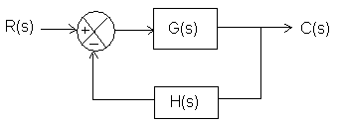
where G(s)= 10/{s(s+1)} ; H(s)=5
Calculate the sensitivity of the closed-loop transfer function, M with respect to the forward path gain G. [7]

2. a) The overall transfer function of a negative feedback system is given by
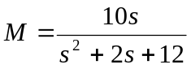
The feedback path transfer function is given by H(s)=1/s. Obtain the open loop transfer function G(s). [6]

b) Obtain the mechanical system for the electrical system shown in figure. [9]
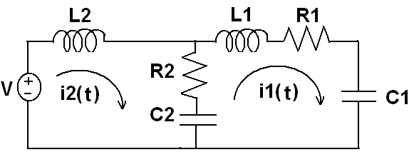
3 A mechanical system is represented as shown in the figure below:
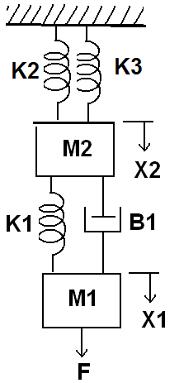
Obtain the mechanical equations and also draw the force voltage analogy and force current analogy of the given system. [15]
4. a) Write down the defining equation for the liquid level system shown in the below figure. Obtain their transfer function also. [7]
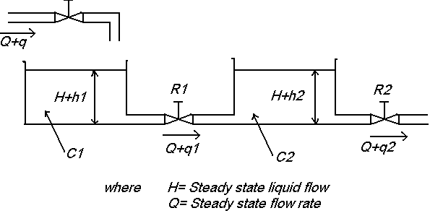

b) Draw the overall block diagram for field controlled DC motor. Also find the overall transfer function. [8]
5. Write short notes on (any two) [5*2=10]
a) Linear approximation of non-linear system
b) Sensors
c) Encoder

